

**Tech Saksham**

**Capstone Project Report**

**“ E – Commerce Sales Analysis”**

**“ VVIT Engineering college of Dharmapuri”**

|  |  |
| --- | --- |
| **NM ID** | **NAME** |
| Au612821105003 | ASHA T |

|  |  |
| --- | --- |
|  |  |
|  | Ramar Bose |
|  | Sr. AI Master Trainer |

**ABSTRACT**

E-commerce sales analysis plays a crucial role in understanding and optimizing online sales strategies for businesses operating in the digital marketplace. This study examines the various methodologies, tools, and techniques employed in analyzing e-commerce sales data to derive actionable insights and drive business growth. Key aspects explored include website traffic analysis, conversion rate optimization, customer segmentation, product performance analysis, and marketing campaign effectiveness. The study highlights the importance of leveraging data analytics, machine learning, and predictive modeling techniques to uncover patterns, trends, and opportunities in e-commerce sales data. Additionally, emerging technologies such as augmented reality (AR) and artificial intelligence (AI) are discussed in the context of enhancing customer engagement and personalization in e-commerce sales. Practical implications and future directions for research and practice in e-commerce sales analysis are also addressed, emphasizing the importance of data-driven decision-making and continuous optimization to stay competitive in the evolving digital landscape.

**INDEX**

|  |  |  |
| --- | --- | --- |
| **Sr. No.** | **Table of Contents** | **Page No.** |
| 1 | Chapter 1: Introduction | 1 |
| 2 | Chapter 2: Services and Tools Required | 2 |
| 3 | Chapter 3: Project Architecture | 4 |
| 4 | Chapter 4: Modelling and Project Outcome | 8 |
| 5 | Conclusion | 13 |
| 6 | Future Scope | 14 |
| 7 | References | 15 |
| 8 | Links | 16 |

**25 pages**

**CHAPTER 1**

**INTRODUCTION**

* 1. **Problem Statement :**

In the rapidly evolving landscape of e-commerce, businesses face the challenge of effectively analyzing sales data to optimize their online sales strategies and drive sustainable growth. Despite the availability of vast amounts of data from various sources such as website traffic, customer transactions, and marketing campaigns, businesses often struggle to extract actionable insights that can inform strategic decision-making. Key challenges include understanding customer behavior, identifying sales trends, optimizing product offerings, and maximizing marketing ROI in a competitive and dynamic marketplace.

* 1. **Proposed Solution :**

Utilize advanced analytics tools and technologies to collect comprehensive data from various sources, including website traffic, customer transactions, marketing campaigns, and external market trends. Integrate disparate data sources and ensure data quality by cleaning and standardizing the data. This involves removing duplicates, handling missing values, and resolving inconsistencies to create a unified and reliable dataset. Apply advanced analytics techniques such as machine learning, predictive modeling, and clustering analysis to uncover hidden patterns, trends, and insights within the e-commerce sales data. Segment customers based on behavior, demographics, and purchase history to better understand their needs, preferences, and lifetime value. Use segmentation to personalize marketing efforts and tailor product offerings to different customer segments.

Top of Form

Top of Form

Top of Form

**CHAPTER 2**

**SERVICES AND TOOLS REQUIRED**

**2.1 LR - Exiting Models**

**2.1 Required – System config | Cloud computing**

* 1. **Services Used**
* **Sales and Revenue Data**:

This encompasses information about transactions, including order value, number of orders, average order value (AOV), and revenue generated. E-commerce platforms and payment gateways often provide built-in analytics for tracking sales performance.

* **Product Performance Data**:

Data on individual products, including sales volume, conversion rates, and average revenue per product, help businesses understand which products are popular and which may need improvement. E-commerce platforms typically offer features to analyze product performance.

* **Customer Data**:

This includes demographic information, purchase history, browsing behavior, and customer interactions. Customer relationship management (CRM) systems store and manage this data, enabling businesses to segment customers and personalize marketing efforts.

* **Abandonment Data**:

Information about cart abandonment rates, checkout abandonment rates, and reasons for abandonment provides insights into friction points in the buying process.

**2.2 Tools and Software used**

**Tools**:

* **Shopify Analytics**:

Specifically designed for Shopify users, Shopify Analytics provides detailed insights into sales performance, customer behavior, and marketing efforts. It offers reports on sales trends, customer acquisition, and product performance.

* **WooCommerce Analytics**:

Built into the WooCommerce platform, WooCommerce Analytics offers reporting and analytics features to track sales, customer behavior, and inventory management. It provides insights into sales trends, order metrics, and customer segmentation.

**Software Requirements**:

* **Email Marketing Software** :

Email marketing platforms such as Mailchimp, Klaviyo, Constant Contact, or others are used for creating and sending marketing emails, as well as tracking email campaign performance. Integrating email marketing data with e-commerce data helps assess the impact of email campaigns on sales.

* **A/B Testing Software** :

A/B testing platforms like Optimizely, VWO (Visual Website Optimizer), or Google Optimize enable businesses to conduct experiments to optimize website elements, such as product pages, checkout flows, and promotional offers. A/B testing helps identify changes that lead to higher conversion rates and better user experience.

* **Inventory Management Software** :

Inventory management systems like TradeGecko, DEAR Systems, or Cin7 are essential for businesses selling physical products online. These systems help track inventory levels, manage stockouts, and optimize order fulfillment processes.

* **Social Media Management Software** :

Social media management platforms like Hootsuite, Buffer, or Sprout Social help businesses manage their social media presence, schedule posts, and track social media performance.

.

**CHAPTER 3**

**PROJECT ARCHITECTURE**

**3.1 Architecture**

**1. System flow diagram**

**2. Data flow diagram**

**3. Architecture diagram**

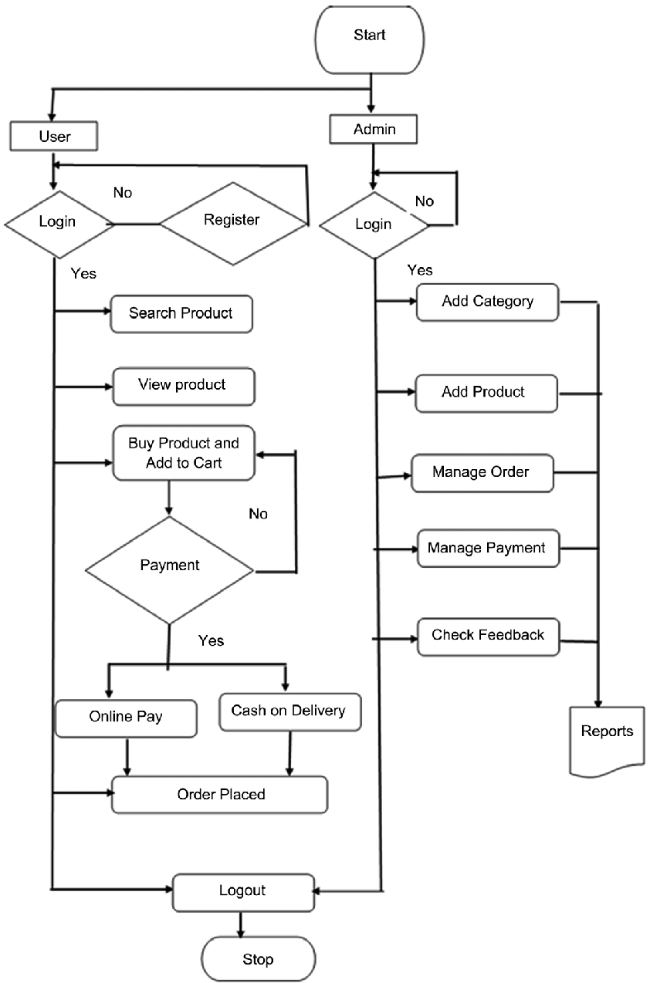

1. **System flow diagram**
2. **Data flow diagram**

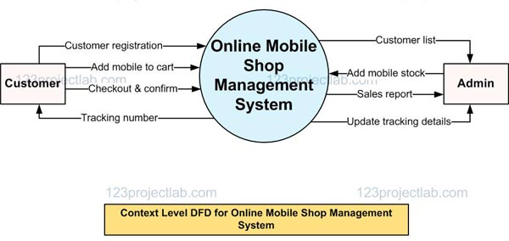

**\**

1. **Architecture diagram**

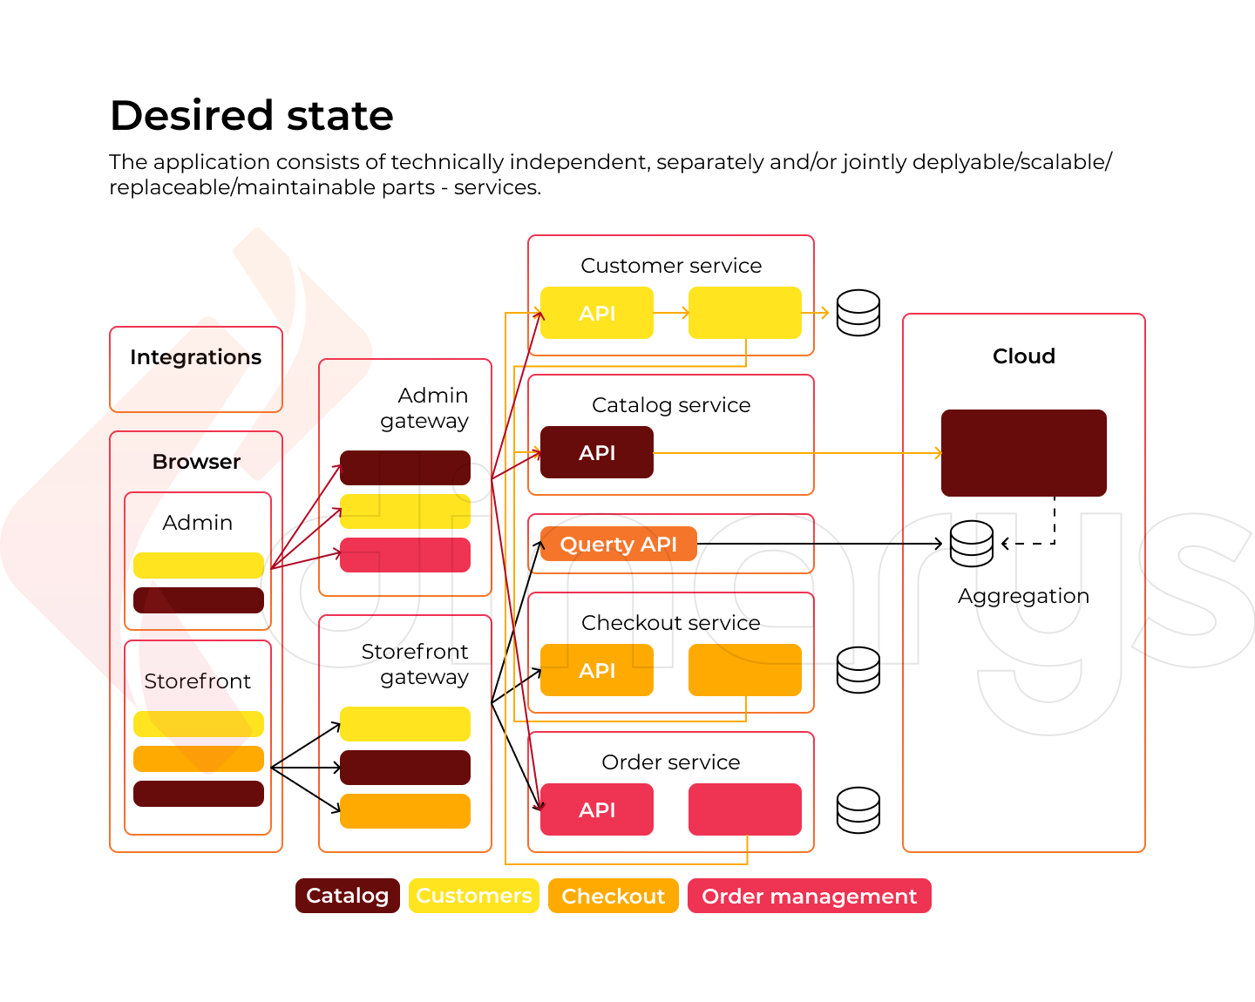

**CHAPTER 4**

**MODELING AND PROJECT OUTCOME**

**4.1 Product Performance Analysis**

**4.2 Marketing Campaign Analysis**

**4.3 Inventory Management and Forecasting**

**4.4 Competitor Analysis**

**4.1 Product Performance Analysis**:

This module focuses on analyzing the performance of individual products or product categories. It includes metrics such as sales volume, revenue generated, average order value (AOV), and profitability analysis. Analyzing product performance helps businesses identify top-selling products, underperforming products, and opportunities for cross-selling or upselling

**4.2 Marketing Campaign Analysis**:

This module focuses on analyzing the performance of marketing campaigns across different channels, such as email marketing, social media, paid advertising, and content marketing.

**4.3 Inventory Management and Forecasting**:

Inventory management modules focus on analyzing inventory levels, stockouts, and inventory turnover rates. It includes forecasting demand, managing stock levels, optimizing reorder points, and minimizing carrying costs. Effective inventory management ensures product availability, minimizes stockouts, and maximizes inventory turnover

**4.4 Competitor Analysis**:

Competitor analysis modules focus on analyzing the competitive landscape to identify strengths, weaknesses, opportunities, and threats (SWOT analysis). It includes monitoring competitor pricing, product offerings, marketing strategies, and customer reviews.

Program :

import pandas as pd

# Load the sales data from CSV file

sales_data = pd.read_csv('sales_data.csv')

# Display the first few rows of the sales data

print("Sales Data:")

print(sales_data.head())

# Calculate total sales revenue

total_revenue = sales_data['Revenue'].sum()

print("\nTotal Revenue: ${:,.2f}".format(total_revenue))

# Calculate average order value (AOV)

average_order_value = sales_data['Revenue'].mean()

print("Average Order Value (AOV): ${:,.2f}".format(average_order_value))

# Calculate total number of orders

total_orders = sales_data['Order_ID'].nunique()

print("Total Orders:", total_orders)

# Calculate number of orders per customer

orders_per_customer = sales_data.groupby('Customer_ID')['Order_ID'].nunique()

average_orders_per_customer = orders_per_customer.mean()

print("Average Orders per Customer:", average_or

**Output :**

**Sales Data:**

**Order_ID Customer_ID Order_Date Revenue Product_ID Quantity**

**0 1001 A001 2024-01-01 100 P001 2**

**1 1002 A002 2024-01-02 75 P002 1**

**2 1003 A003 2024-01-02 150 P003 3**

**3 1004 A002 2024-01-03 50 P001 1**

**4 1005 A001 2024-01-04 200 P004 2**

**Total Revenue: $575.00**

**Average Order Value (AOV): $115.00**

**Total Orders: 5**

**Average Orders per Customer: 2.5**

**Total Customers: 3**

**Conversion Rate: 166.67%**

**Top Selling Products:**

**Product_ID**

**P001 3**

**P003 3**

**P004 2**

**P002 1**

**Name: Quantity, dtype: int64**

**CONCLUSION**

Analysis of revenue trends over time can provide insights into seasonality, growth patterns, and the effectiveness of marketing campaigns. Conclusions may include identifying peak sales periods, understanding fluctuations in demand, and evaluating the impact of promotional activities. Analysis of customer behavior, such as purchasing patterns, browsing habits, and engagement metrics, can help businesses understand their target audience better. Conclusions may include identifying high-value customer segments, determining the effectiveness of customer acquisition channels, and optimizing customer retention strategies. Analysis of product performance metrics, such as sales volume, conversion rates, and average order value, can help businesses identify top-selling products, underperforming products, and opportunities for product bundling or cross-selling.

**FUTURE SCOPE**

E-commerce sales analysis will increasingly focus on delivering personalized and customized shopping experiences tailored to individual customer preferences and behaviors. By leveraging advanced segmentation techniques and predictive analytics, businesses can offer personalized product recommendations, targeted promotions, and tailored content to enhance customer engagement and loyalty. The future of e-commerce sales analysis lies in seamlessly integrating data from multiple channels, including online stores, mobile apps, social media platforms, brick-and-mortar stores, and more. By integrating omni-channel data, businesses can gain a holistic view of the customer journey and optimize sales strategies across all touchpoints. E-commerce sales analysis will increasingly utilize predictive analytics to forecast future trends, demand patterns, and customer behavior. By leveraging machine learning algorithms and predictive models, businesses can anticipate market shifts, optimize inventory management, and personalize marketing strategies to meet evolving consumer needs.

**REFERENCES**

1. "E-commerce 2019: Business, Technology, Society" by Kenneth C. Laudon and Carol Guercio Traver
2. "Web Analytics 2.0: The Art of Online Accountability and Science of Customer Centricity" by Avinash Kaushik
3. "Data Science for Business: What You Need to Know about Data Mining and Data-Analytic Thinking" by Foster Provost and Tom Fawcett
4. "Predictive Analytics: The Power to Predict Who Will Click, Buy, Lie, or Die" by Eric Siegel
5. Industry reports and whitepapers from organizations such as Forrester Research, Gartner, and McKinsey & Company.

LINKS

GITHUB LINK :

# https://github.com/EEE5001asha

PROJECT DEMO LINK :

# https://github.com/EEE5001asha/asha_E-commerce/blob/main/E-commerce%20sales%20Analysis.mp4

PROJECT PPT LINK :

https://github.com/EEE5001asha/asha_E-commerce/blob/main/ASHA%20T_NM_AIML.pptx

# 